 **LAB # 05**

Submitted by:

**Maaz Habib**

Registration No.:

**20PWCSE1952**

Class Section:

**C**

Student Signature: ______________

Submitted to:

**Engr. Muniba Ashfaq**

January 31, 2024

**Department of Computer Systems Engineering**

**University of Engineering and Technology, Peshawar**

**Task 01:**

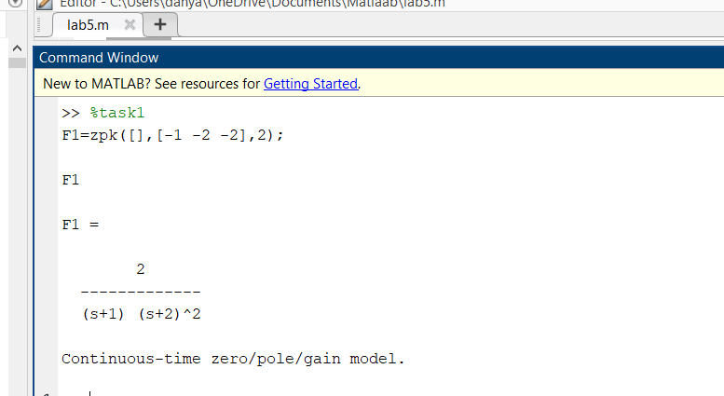

**Task 02:**

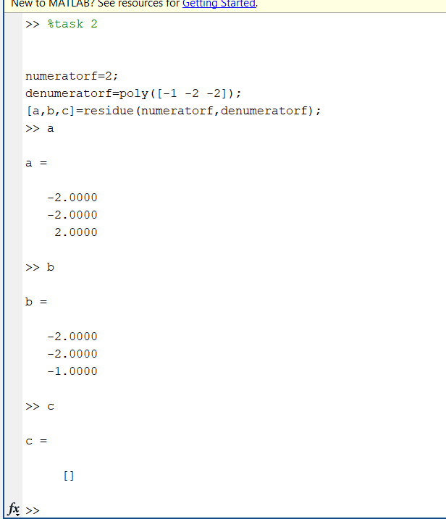

**Task 03:**

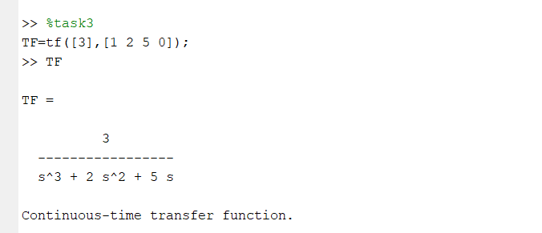

**Task 04:**

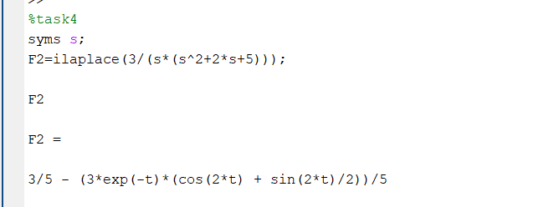

**Task 05:**

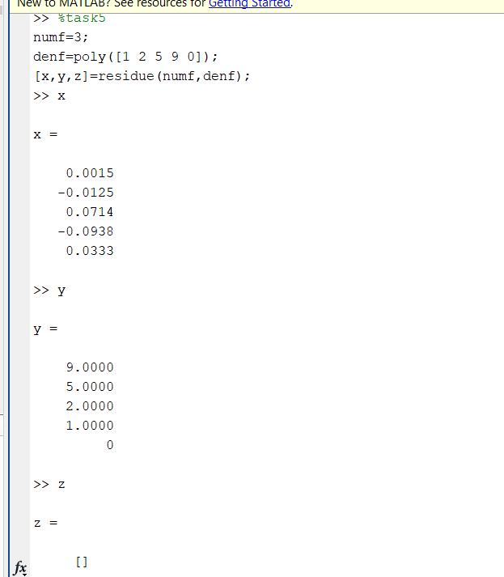

**Task 06:**

**Task 07:**

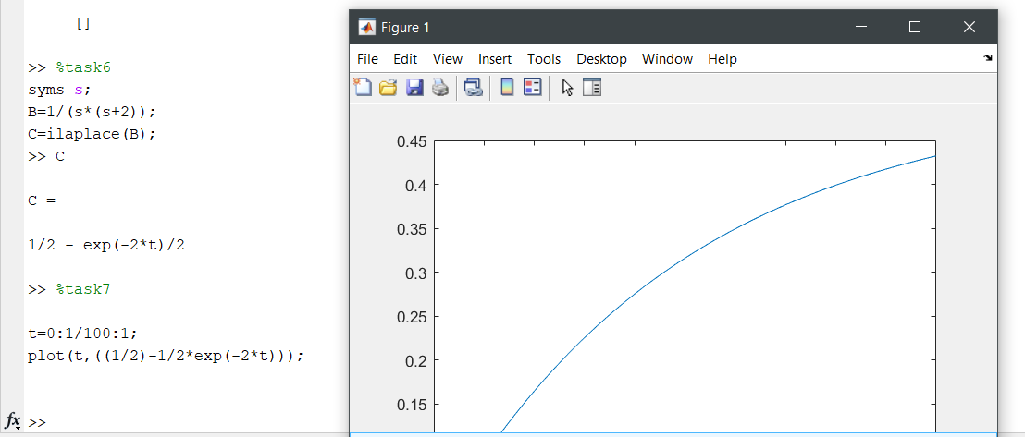

**Task 08:**

